Changes in 611 beta

# Screens

|  |  |  |  |
| --- | --- | --- | --- |
| Screen Name | Screen Number | Products | Change |
| UTILITIES | 5 | CCM & EEA | Removed Periodic Self Tests. Tests no longer run. |
| CCM MAIN | 500 | CCM | Added Water-cut by density display. |
| ADJUSTMENTS | 52 | EEA | Allowed Stream to be changed when Master Lock engaged. |
| STREAM ADJUSTMENTS | 57 (EEA),  112 (EEA),  213 (CCM&EEA),  214 (CCM&EEA), 312 (EEA),  412 (EEA) | CCM & EEA |
| AUTO CAL OIL | 802 | EEA |
| AUTO CAL WATER | 803 |
| STREAM OIL+WATER | 504 | CCM & EEA |
| STREAM OIL | 505 | CCM & EEA |
| STREAM WATER | 506 | CCM & EEA |
| CCM TEST SETUP | 507 | CCM |
| Allowed Test to start when Master Lock engaged. |
| Allowed Accumulators to be cleared when Master Lock engaged. |
| Removed Enable Accumulator button, accumulators are always enabled. |
| CCM FC ADJUSTMENTS | 555 | CCM | Filters are now locked in Master Lock. |
| HEURISTIC SALNITY | 210 | EEA | Moved Heuristic Enabled to this screen  Added Delta T  Added Manual Reset  Added Counter Reset  Added Time Reset Enabled  Added Minutes for Time Reset |
| HEURISTIC TRIGGERS | 560 | CCM |
| FLOW COMPUTER DENSITY | 611 | CCM & EEA | Changed ‘Save’ method to same as others. |
| FLOW COMPUTER VARIABLES | 612 | CCM & EEA |
| LIQUID CORIOLIS 1 | 531 | CCM | Added Drive Gain for Liquid and Gas MicroMotions |
| GAS CORIOLIS 1 | 532 |
| GAS FLOW | 503 | Density is now COR[1].density not CCM_GAS_DENSITY |
| FC1 DENS CORR | 608 | EEA | Changed Correction Mode to first prompt  Moved Port to second prompt  Port is locked when correction disabled (blank) |
| DC PORT | 685 | Removed Modbus Port1, only 3 and 4 available for Micro Motion. |
| ANA DETAILS 2 | 54 | Added Density and Gross Flow for PPM |
| FC1 ACCUM | 601 | CCM & EEA | Added Average Gross and Net Watercuts |
| VESSEL | 502 | CCM | Extended Setpoint to 200% |
| CCM LIQ UNITS | 510 | Added CCM Physical Operation Level Input |
| CCM LIQ UNITS 2 | 516 | Moved TEMP, PRESS, FC TEMP and DENSITY for CCM to this screen. |

# Program

|  |  |  |  |
| --- | --- | --- | --- |
| Change | Products | Screen Name | Screen Number |
| Self Tests have been functionally removed. | CCM & EEA | UTILITY | 5 |
| Changed Default Password | CCM & EEA | SECURITY | 703, 497 |
| Updates Water-cut by density on all CCMs. | CCM | CCM MAIN | 500 |
| Accumulator initialized to ON  Accumulators are turned back on after reset.  If heuristic enabled, it resets when counters are reset. | CCM | CCM TEST SETUP | 507 |
| Changed Temp Trigger Reset  Note: Triggers on absolute value of Delta T  You can now reset Heuristic Salinity manually.  Added Time Reset  Note: Triggers when a new lower frequency is  found – resets to lowest frequency in window.  If heuristic enabled, it resets when counters are reset. | CCM | HEURISTIC TRIGGERS | 560 |
| EEA | HEURISTIC SALINITY | 210 |
| Unlocked MODBUS to be used through MODBUS Com1. Screens are still locked and unaffected. | CCM & EEA | N/A | N/A |
| **Drive gain is now read from Gas MicroMotion** | CCM | GAS CORIOLIS 1 | 532 |
| **Log now uses CCM_GAS_LIVE_DENSITY**  **NOT CCM_GAS_DENSITY** | CCM | N/A | N/A |
| **Made it impossible for DCM port to be 2.** | CCM & EEA | FC1 DENS CORR | 608 |
| **Calculates Gross and Net Watercuts**  **Added a screen to the 4-line LCD press SELECT at Main Menu to see it.** | CCM & EEA | FC1 ACCUM | 601 |
| **Net Flow enabled by default** | CCM & EEA | FC1 SETUP | 604 |
| **CCM_GAS_LIVE_DENSITY displays corrected, raw MM Density.** | CCM | GAS FLOW | 503 |

# Configuration

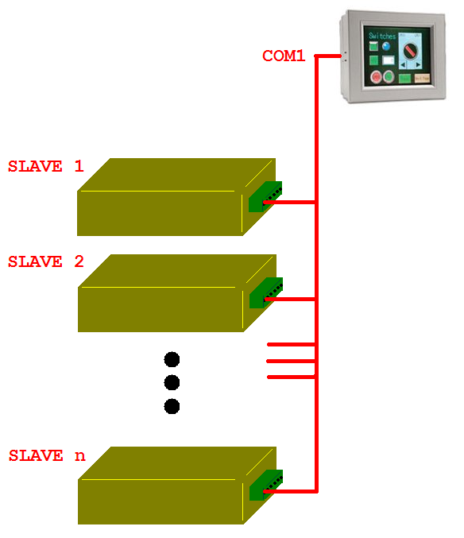A new configuration option has been engineered that allows for   
multiple Stand Alone Analyzers to be controlled and read by one   
IDEC Touch Screen over COM1.

Figure : Multiple Standalone Analyzers Schematic